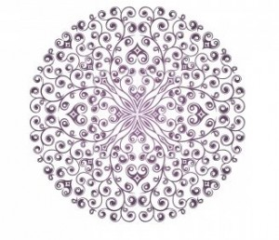_____________________________________________________________

Om Namah Shivaya Gurave

Satcitananda Murtaye

Nish Prapanchaya Shantaya

Niralambaya Tejase

OM
A sacred syllable symbolizing the Absolute, the Universal Energy that lives in all of us. Om represents the “soundless sound,” the eternal vibration of life essence. As science has discovered, there is a constant subtle hum to the universe; yogis know that we are all connected by these harmonics of being. Om is the vibration that the universe is making at its most subtle and sublime level. It helps stimulate the vagus nerve and our parasympathetic nervous system to rest and restore rather than fight and flight.

Namah Shivaya. Namah means to honour or to bow with respect. Shiva translates literally as “good.” The chant says, “I recognize that the essence of being is goodness, and I honour this goodness in myself and in all beings.”

Gurave. Gu means “darkness,” and ru means “remover,” or “destroyer.” Gurave means to bow to the teacher, especially the teacher within. The guru can be your partner, your children, your dog, or even a place in nature that speaks to you.

Sat-cit-ananda Literally, Being/Truth, Consciousness, Bliss. The ease of being. The phrase describes a moment of awareness resting in its true nature, like a drop of ocean water being absorbed into the ocean.

Murtaye means in the image of. Murtaye can apply to literal images of Buddha, etc. or to the inner image one creates of oneself.
Nishprapancaya Never not present. This word refers to a current or river of life energy, prana, or life force, that always runs through our lives.
Shantaya Full of peace – shanti means “peace” and refers to a balance of mind.

Niralambaya Tejase - A quality of light or illumination that exists eternally and is independent in its existence. Shines with a divine sparkle!

